CARBON


& its compounds
Handwritten No

Carbon
- Carbon is Non-Metal. Its symbol is C.
- All the living things, Plants and animals are made up of Carbon.
- Carbon always forms covalent bonds
- The atomic number of carbon is 6.

Element configuration
K L
C(6) 2 4
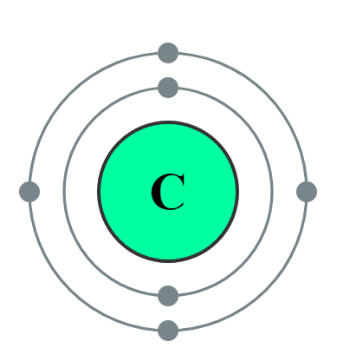

Covalent Bond

- A covalent bond is formed when pairs of electrons are shared between two atoms.
- It is mostly formed between two same nonmetallic atoms or between nonmetallic atoms.

Examples of Covalent Bonding

1) Single Bond in Hydrogen (H₂)
Hydrogen needs 1 more e- in outermost shell to complete octet.



H + H
H H Or H-H

- Double Bond in Oxygen (O₂)
Oxygen needs 2 more e- in outermost shell to complete octet.

O + O
O O Or O=O

- Triple Bond in Nitrogen (N₂)
Nitrogen needs 3 more e- in outermost shell to complete octet.
N
N

+
N
N
Or N=N

4) Water (H₂O)
Oxygen needs 2 e to complete its octet while Hydrogen needs 1 e, So Oxygen shares one-one electron from 2 hydrogens to complete its octet.



H + O + H
H O H

Or H-O-H

Physical Properties of Covalent Compounds

- Covalent compounds have low melting and boiling points as they have weak intermolecular force.
- They are generally poor conductor of electricity as electron are shared between atoms therefore no charged particles are formed.

How carbon attain Noble gas configuration?

Carbon is Tetravalent, it does not form ionic bond by either losing four electrons (C4+) or by gaining four electrons (C4-). It is difficult

to hold four extra electron and would require large amount of energy to remove four electrons. So, carbon can form bond by sharing of its electrons with the electrons of other carbon atom or with other element and attain noble gas configuration.

Versatile Nature of Carbon

The three characteristic properties of carbon element which lead to the formation of large number of compounds.

  - Catenation -
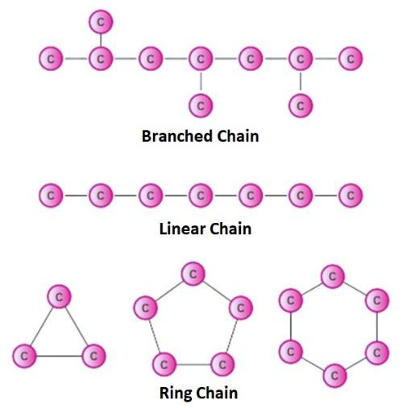
The self-linking of atoms of an element to create chains and rings by covalent bonds.

2) Tetravalency –
Carbon has 4 valence electrons. Carbon can bond with four carbon atoms, monovalent atoms, oxygen, nitrogen and sulphur.

- Tendency to form Multiple Bonds –
Due to its small size carbon has a strong tendency to form multiple bonds (double and triple bonds) by sharing more than one electron pair with its own atoms or with the atoms like oxygen, nitrogen etc.

Allotropes of Carbon

Allotropy is the property by which an element exists in more than one form and each form has different Physical Properties but similar Chemical Properties.

Diamond

  - It is formed by bonding of each carbon atom is Covalently bonded to four other forming Rigid 3-D Structure.
  - It is the hardest thing on Earth.
  - It is a bad conductor of electricity. This is because all the valence electrons of each Carbon are involved in the Covalent Bonding, and no unpaired electrons are left in the crystal.

  - It has very high melting point.
  - It is used for making Jewellery and cutting Glasses

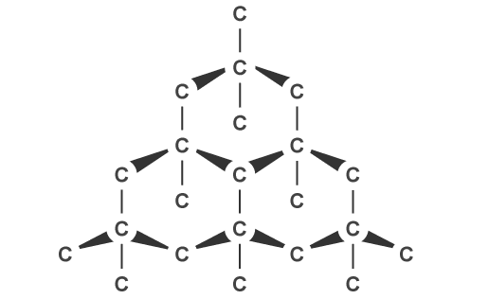
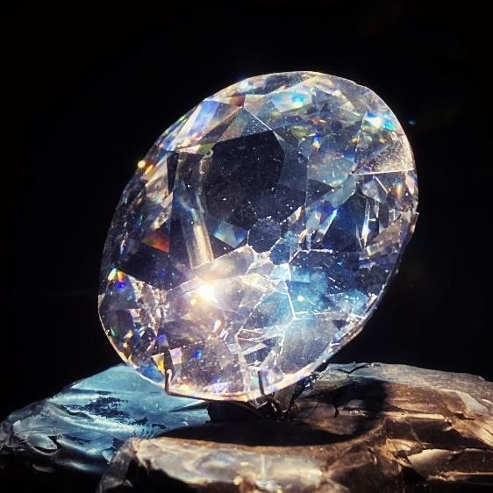

Kohinoor Structure of Diamond

Graphite

  - It is formed by bonding of each carbon atom hexagonally (six- member rings) in same plane.
  - It is very soft and slippery because Layers can slide over one another.
  - It is a good conductor of electricity because in graphite every carbon is bonded with three other carbon atoms. So last electron in every carbon atom is free to move.
  - It is used for making Pencil Leads, Engine Oils, Batteries and Cells

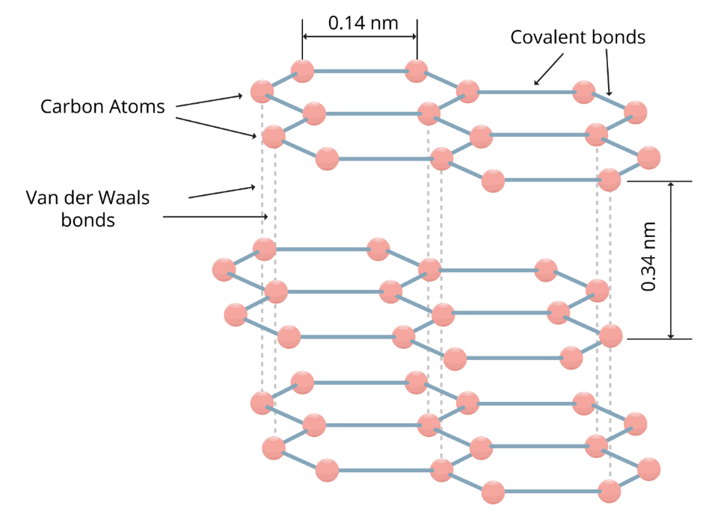
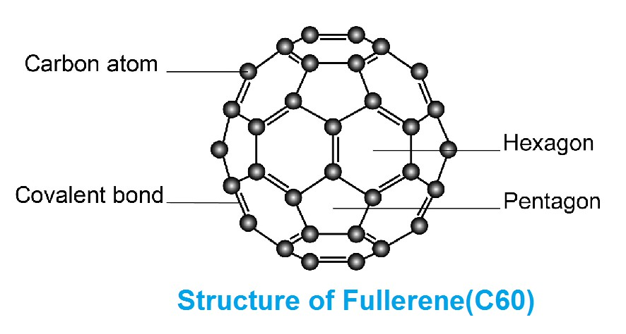
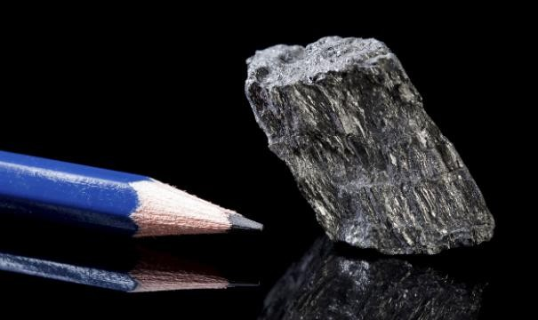
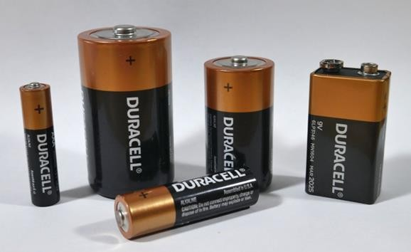

Fullerene

  - Fullerenes form another class of carbon allotropes.
  - First one to be identified was C – 60, which has carbon atom arranged in the shape of football.
  - It has 12 pentagons and 20 hexagons.

Hydrocarbon
Compounds made up of hydrogen and carbon are called hydrocarbon.

Hydrocarbon

Saturated Unsaturated

Saturated -

Compounds of carbon which are linked only by single bonds between the carbon atoms.

Types of saturated hydrocarbons -

Alkanes - The hydrocarbons in which all the carbon atoms are linked by only single covalent bonds are called alkanes.
General formula - C_{n}H_{2n+2} Example -
H H

H C C H
H H
Ethane (C₂H₆)

Unsaturated -
Compounds of carbon having double or triple bonds between their carbon atoms.

Types of Unsaturated hydrocarbons -

Alkenes – Those unsaturated hydrocarbons which have at least one double bond along with single bonds are called alkenes.
General formula - C_{n}H_{2n} Example -
H H
H C C H
Ethene (C₂H₄)

Alkynes - Those unsaturated hydrocarbons which have one or more triple bonds along with the single bonds are called alkynes.
General formula - C_{n}H_{2n-2} Example -
H C C H

Ethyne (C₂H₂)

IUPAC Nomenclature of Hydrocarbons


Name of Hydrocarbon = Prefix + Suffix
Prefix – Based on Number of carbon atoms in the chain.

No. of Carbons Present | Prefix
1 | Meth
2 | Eth
3 | Prop
4 | But
5 | Pent
6 | Hex
7 | Hept
8 | Oct
9 | Non
10 | Dec

Based on type of Bond
Suffix –
For Single Bond - (Alkane → ane) For Double Bond - (Alkene → ene) For Triple Bond - (Alkyne → yne)

For Example -
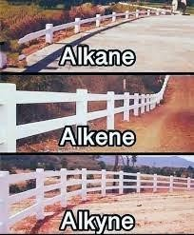

CH₃ CH₃
CH₃
CH₂ CH₃

CH₂ CH₂

C CH
Propane Propene Propyne

Carbon Compounds on the Basis of structure

Straight (unbranched) chain

H H H
H C C C H
H H H

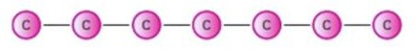

2) Branched chain
H H H

H C C C H
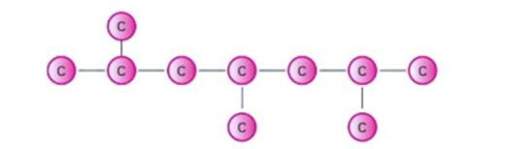
H
H
C
H
H
H
3) Cyclic Chain
H
H
H C C
H
H C C
H
H
H

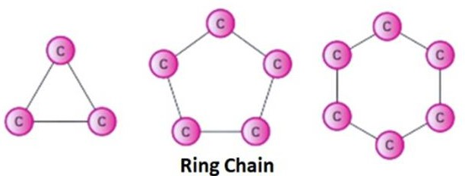


Cl
Functional Groups

- An atom or group of atom that makes a carbon compound reactive
and decides its chemical property is called a functional group.

Functional Group | Family | Suffix
OH | Alcohol | ol
O  C H | Aldehyde | al
O C | Ketones | one
O  C OH | Carboxylic Acid | oic acid
Cl or Br | Halogen (Chlorine, Bromine) | chloro, bromo (Prefix)

Steps of Nomenclature

Prefix + Root Word + Suffix

Step 1) - Identify the number of carbon atoms in compounds. It will give us Root Word (like Meth, Eth, Prop, etc).
Step 2) - Identify the type of bond (single, double, triple) between carbon atoms. It will give us Suffix (like -ane, -ene, -yne).
Step 3) - Identify the Functional group. It will give us Suffix (like
-one, -ol, -al) or Prefix (like Chloro, Bromo).

Homologous Series

- A series of carbon Compound in which same functional Group and differ by CH₂ are known as Homologous Series.

Example –
Alcohols – CH₃OH, C₂H₅OH, C₃H₇OH, C₄H₉OH

Some Properties -
- All members are represented by same General Formula
- 2 adjacent members differ by -CH₂ group.
- 2 adjacent members differ by molecular mass of 14u.
- All shows similar chemical properties. (but not physical)

Chemical Properties of Carbon Compounds

1) Combustion -
- A chemical reaction in which heat and light are given out is called combustion.

  - Combustion of Carbon -

C + O₂ CO₂ + Heat + Light

  - Combustion of Hydrocarbon -

CH₄ + O₂ CO₂ + H₂O + Heat + Light

  - Combustion of Alcohol -

CH₃CH₂OH + O₂ CO₂ + H₂O + Heat + Light

Oxidation –

  - Alcohols can be converted to carboxylic acid in the presence of oxidizing agent Alkaline KMnO4 (potassium permanganate) or K₂Cr₂O₇ Acidified potassium dichromate.

Alkaline KMnO4
CH₃–CH₂–OH CH₃COOH
Acidified K2Cr2O7
(ethanol)

Catalyst
A substance that makes a chemical reaction happen faster, without being used up in the reaction.
Examples - Nickel(Ni), Palladium(Pd), Potassium permanganate (KMnO₄), Potassium dichromate (K₂Cr₂O₇)

Addition Reaction -

  - Unsaturated hydrocarbons add hydrogen in the presence of catalyst such as palladium or Nickel to give saturated hydrocarbons

Ni or Pd
CH₂ CH₂ CH₃ CH₃

(ethene)
H2 (ethane)

Above reaction is also known as Hydrogenation reaction.

Uses of Hydrogenation Reaction -

    - Vegetable oils are converted into vegetable ghee using this process.
    - Animal fats generally contain saturated fatly acid which are harmful for health.

4) Substitution Reaction -
  - It is a single replacement chemical reaction during which one functional group in chemical compounds is replaced by another functional groups.
Example -
CH₃OH + HBr CH₃Br + H₂O

Sunlight
CH₄ + Cl₂ CH₃Cl + HCl

Important Carbon Compounds Ethanol (CH₃CH₂OH)

Physical Properties of Ethanol -

- Colourless, Good smell and Burning taste.
- Ethanol is Liquid, soluble in water
- Ethanol is commonly called alcohol and is the active ingredient of Alcoholic drinks.
- Ethanol is a good solvent, so it is used in medicines such as tincture iodine, cough syrups and many tonics.

Chemical Properties of Ethanol -
1) Reaction with Sodium -

2CH₃–CH₂–OH + 2Na 2CH₃CH₂ONa + H₂
(sodium ethoxide)

This reaction is used as a test for ethanol by evolution of H₂ gas (Burn with pop sound).

Dehydration –

Hot concentrated
CH₃–CH₂–OH CH₂ CH₂ + H₂O
H2SO4
(ethanol)

Hot concentrated H₂SO₄ act as Dehydrating Agent

Ethanoic Acid (CH₃COOH)

Physical Properties of Ethanoic acid -

- Ethanoic acid is also known as Acetic Acid.
- Melting point of pure ethanoic Acid is 290 K.

- Solution of Acetic Acid in water is called Vinegar and is used as preservative in pickles
- Ethanoic Acid is weak acid.

Chemical Properties of Ethanoic Acids -

1) Esterification Reaction –
Reaction of Acid and Alcohol gives Ester.

CH₃-COOH + CH₃–CH₂–OH
Acid
CH₃-COOCH₂CH₃ + H₂O

(Ethanoic Acid)
(Ethanol)
(ethyl acetate ester)

- Esters are sweet smelling substances
- Used in Making Perfumes and as Flavouring Agents.

Saponification Reaction

This reaction is used in for making Soap.
Ester + Base → Alcohol + Soap

Example –

CH₃–COOCH₂CH₃
(Ester)

NaOH

CH₃CH₂OH + CH₃COONa
(Ethanol) (Soap)

2) Reaction with base (Neutralisation Reaction) –

CH₃COOH + NaOH CH₃COONa + H₂O

  - Reaction with Carbonates -

2CH₃COOH + Na₂CO₃ 2CH₃COONa + H₂O + CO₂

  - Reaction with Hydrogen carbonates -

CH₃COOH + NaHCO₃ CH₃COONa + H₂O + CO₂

Distinguish between Ethanol & Ethanoic acid
We can distinguish experimentally between alcohol and Carboxylic acid by reacting them with sodium Carbonate, turning lime water milky. Alcohols do not react to give lime water milky

Soaps and Detergents

Soap -
- Soap is sodium or potassium salt of long chain carboxylic acid.
Example –
C₁₇H₃₅COONa⁺
- Soaps are effective only in soft water.

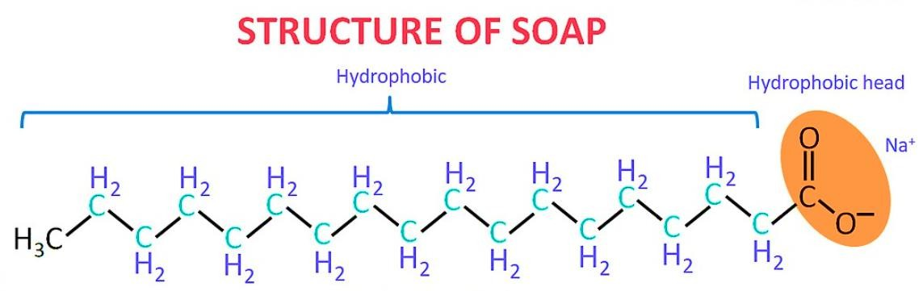
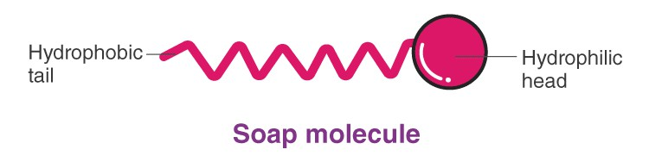

Soap molecule has –
    - Ionic (hydrophilic part)
    - Long hydrocarbon chain (hydrophobic part)

Example of Soaps -
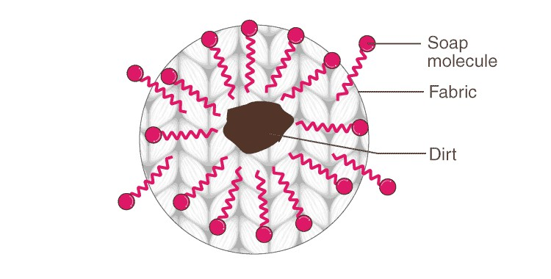
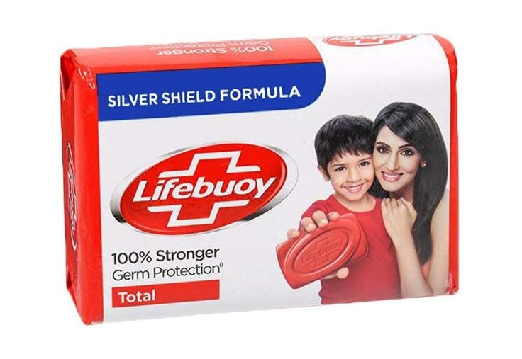

Cleansing Action of Soap

- When soap is added to water, the soap molecules uniquely orient themselves to form spherical shape micelles.

- The non-polar hydrophobic part or tail of the soap molecules attracts the dirt or oil part of the fabric, while the polar hydrophilic part or head,(−COO−Na+, remains attracted to water molecules.
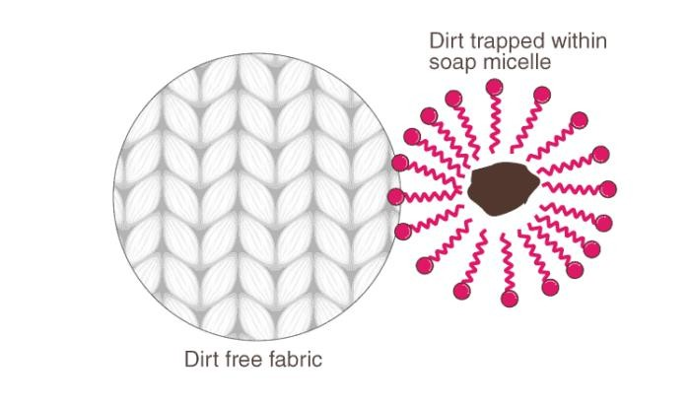
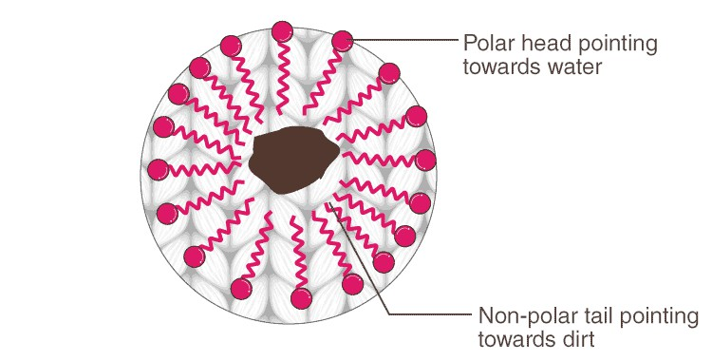

- The agitation or scrubbing of the fabric helps the micelles to carry the oil or dirt particles and detach them from the fibres of the fabric.

Detergents -
- Detergents are ammonium or sulphonate salt of long chain of carboxylic acid.
- Detergents are effective in both hard and soft water.

Example of Detergents -

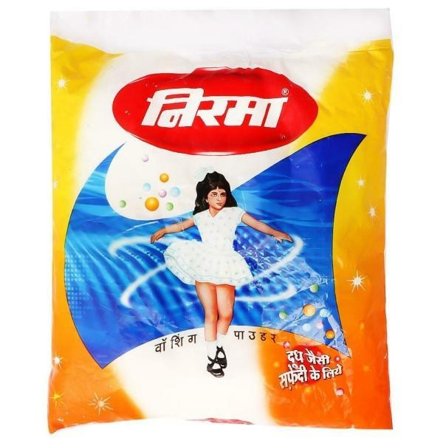

Hard Water
- Hard water means, water having a very high amount of minerals like Calcium and Magnesium
- When soap is added to hard water, calcium and magnesium ions of hard water react with soap forming insoluble product called Scum. This scum create difficulty in cleansing action.
- By use of detergent, insoluble scum is not formed with hard water and cloths get cleaned effectively. So, Detergents can only be used in Hard Water but not Soap.

